Software Requirements Specification
(Analysis Model)
for the
Coffee Maker II System

Submitted by

Dr. David A. Workman
COP 4232

July 1, 2003
Revised: July 9,14, 2003
Revised: December 12, 2003
By Jennifer Cardona
Table of Contents

1.0 Introduction 1
1.1 Document Purpose 1
1.2 Document Scope 1
1.3 Definitions, Acronyms, and Abbreviations 1
1.4 References 3
1.5 Document Overview 3

2.0 Overview and Summary of the CM2SS 3
2.1 Product Perspective (Motivation and Business Analysis) 3
2.2 Product Functions 4
2.2.1 CM2S Operation (World Model) 4
2.2.2 CM2S Physical Design and User Interfaces (World Model) 7
2.2.3 CM2SS Operational Concept (The Simulator) 8
2.2.4 CM2SS User Interfaces (The Simulator) 10
2.3 User Characteristics 10
2.4 Constraints 10
2.5 Assumptions and Dependencies 10

3.0 Specific Requirements 11
3.1 External Interfaces 11
3.1.1 CM2S Model Interfaces 11
3.1.2 CM2SS Simulator Interfaces 11
3.2 Product Functions (Use Cases) 11
3.2.1 Use Case Specifications: CM2S 11
3.2.1.1 [Dis]Connect Power Source 11
3.2.1.2 Set Brew Time 13
3.2.1.3 Brew Coffee 14
3.2.1.4 Set Wall Time 16
3.2.1.5 Fill Coffee Basket 17
3.2.1.6 Remove/Replace Basket 17
3.2.1.7 Insert/Remove Carafe 17
3.2.1.8 Fill Water Reservoir 18
3.2.1.9 Toggle Brew Mode 18
3.2.1.10 Toggle Hot Plate Switch 19
3.2.2 Operational States: CM2S 19
3.2.3 Use Case Specifications: CM2SS 22
3.2.4 Operational States: CM2SS 24
3.3 Performance Requirements 26
3.3.1 Safety Requirements 26
3.3.2 Performance Requirements 26
3.3.3 Usability Requirements 26
3.4 Logical Database Requirements 27
3.5 Design Constraints 27
3.6 Software Quality Requirements 27
3.7 Object Models 27
3.7.1 Software Architectural Overview 27
3.7.2 Subsystem and Package Specifications 34
3.7.3 Class Specifications 34
3.8 Implementation Issues 34

List of Figures

Figure 1.1. Use Case Diagram for Coffee Maker II System 5
Figure 1.2. Coffee Maker II System Physical Design 7
Figure 1.3. Control Console 8
Figure 1.4. Transitions Controlling the Hotplate 20
Figure 1.5. Transitions and Events Controlling the Brew Cycle 20
Figure 1.6. Time Display Control States and Transitions 21
Figure 1.7(a). Brew Timer Control and Transitions 21
Figure 1.7(b). Wall Timer Control and Transitions 21
Figure 2.1. Collaboration Diagram for Set Brew Time 13

1.0 Introduction

1.1 Document Purpose

This document specifies an internal software architecture for a discrete-event simulation of the Coffee Maker II system (CM2SS) that realizes the functional requirements presented in the Use Case Model for the Coffee Maker II system (CM2S). This document therefore establishes a baseline software solution and is intended as a technical reference for all steak holders, specifically the client, CafAdiksTM Home Products, and the software developer, COP 4232, Inc. Approval and acceptance of this document by the client organization is necessary before proceeding with the development of a complete software design and construction of the CM2SS.

1.2 Document Scope

This document presents a high-level software architectural view of the Coffee Maker II Simulation System (CM2SS). This document does not contain a complete design satisfying all requirements, nor is it intended as a non-technical end-user guide of the Coffee Maker II system. It is a specification of a software solution that satisfies all functional requirements and therefore serves as the basis for continuing the software design of a discrete event simulation of the internal function of the Coffee Maker II system as defined by the Use Case Model, dated June 4, published by COP 4232.
The CM2SS will enable CafAdiksTM Home Products to rapidly reconfigure and evaluate alternative internal designs of the Coffee Maker II system thereby reducing the risk of poor operational performance in the final product.

1.3 Definitions, Acronyms, and Abbreviations

CM2S: Coffee Maker II System – this is the system being modeled and simulated. Synonym: World Model.
CM2SS: CM2S Simulator. This refers to the software system being specified by this SRS. It denotes the tool that encapsulates the World Model and simulates instances of this model according to the requirements established in this document and others (See References).

Coffee Grounds: This refers to the granular substance made from raw coffee beans through a process of grinding. The granules (grounds) are blanched with hot water during the brew cycle to produce hot coffee. Coffee grounds are usually placed in the CM2S coffee basket wrapped in a special paper filter that removes undesirable solid by-products of the blanching process and prevents the coffee grounds themselves from entering the coffee carafe that catches the brewed coffee.

Water Reservoir. This refers to the CM2S internal tank that holds water in preparation of executing a brew function. This reservoir has a lid on top of the CM2S that is manually opened to facilitate filling. It has an external indicator that displays the water level in the reservoir.

Carafe: This is a removable glass pyrex container that serves as a receptacle for hot brewed coffee produced by CM2S during its brew cycle. It serves a secondary function of providing a convenient dispensing device for the user when pouring brewed coffee into external containers, such as coffee cups. Finally, it serves a third function of providing a convenient water container for filling the CM2S water reservoir in preparation to coffee brewing.

Brew Cycle: This refers to the primary (brew) function of the CM2S of brewing coffee by heating water held in the water reservoir and dripping it over coffee grounds held in the coffee basket to produce brewed coffee held in the CM2S carafe.

Liquid Element Display (LED): The square red colored window in the center of the Control Console. See Figures 2 and 3. This display panel shows various status indicators: brew mode (manual | auto), time display mode (wall time | brew time), and AM/PM indicator. It also gives a read-out of the current value of Wall Time or Brew Time as determined by the value of the time display mode indicator.

Control Console: The front face at the base of the Coffee Maker II system consisting of various buttons, the LED display panel, and various status lights. See Figures 2.2-2 and 2.2-3.

Coffee User: This refers to the actor who interacts with the Coffee Maker II System. This actor can be anyone who is capable of brewing coffee.

Hotplate: This refers to the disk at the base of the Coffee Maker II System. This plate maintains a temperature of 100° Fahrenheit when turned on. The carafe sits on the hotplate and the hotplate is used to keep the brewed coffee warm.

Water Level Indicator: The Water Level Indicator is located along the side of the water reservoir. It indicates how much water is in the reservoir at any time. It is a graduated scale measured in cups. Alias: Indicator

Power Source: This refers to the system that the Coffee Maker II System will receive power from. The power source provides a grounded source of 110 Volt AC current.

Power Switch: This is a switch located on the control console. When the switch is in the ON position, the Coffee Maker II System will receive power from the power source. When the switch is in the OFF position the Coffee Maker II System will now receive power.

Coffee Basket: This is the basket in the Coffee Maker II System that holds the coffee grounds. It is a removable basket that is lined with a filter and then filled with coffee grounds before the brewing process begins.

Coffee Filter: This refers to the liner that is placed between the coffee basket and the coffee grounds. This filter allows only the coffee to pass through to the carafe while the coffee grounds stay in the basket.

Spring Valve: This refers to a valve that automatically shuts off the flow of brewed coffee when the Carafe is removed from its position on the Hot Plate. This reduces the potential for overflow water causing damage to the environment as well as the electrical components of the Coffee Maker II itself. This is also a convenience to the Coffee User by permitting the Carafe to be removed for a brief time period (early cup of coffee) and replacing it before the Coffee Basket capacity is exceeded.

Time Display Panel: The square red colored window in the center of the Control Console. See Figures 2.2-2 and 2.2-3. This display panel shows various status indicators: brew mode (manual | auto), time display mode (wall time | brew time), and AM/PM indicator. It also gives a read-out of the current value of Wall Time or Brew Time as determined by the value of the time display mode indicator.

1.4 References

[1] A Use Case Model for the Coffee Maker II System, published June 4, 2003, by Dr. David Workman on behalf of the software vendor, COP 4232, Inc.

[2] IEEE standard 830-98, A Guide to Software Requirements Specificaiton, published by the IEEE Standards Organization, 1998.

1.5 Document Overview
Section 2 presents an overview of the Coffee Maker II Simulation System. This is intended as an executive summary of the simulator, its functional capabilities and its user interfaces. Section 3 contains a specification of the software architecture of the CM2S simulator and how it demonstrates the functional capabilities of the CM2S.

2.0 Overview and Summary of the CM2SS

2.1 Product Perspective (Motivation and Business Analysis)

CafAdiksTM Home Products, hereafter referred to as “CafAdiks”, has observed declining sales of its current Coffee Maker system in the last three quarters due to a new line of coffee makers introduced by its competitors within the last year. As a consequence of this sales trend, the Marketing department of CafAdiks conducted a customer satisfaction survey (see Appendix A). The results of this survey (1000 customers responded) clearly indicate that customers are dissatisfied with the lack of features compared with CafAdiks’s competitors. Foremost among the deficiencies cited by customers is the lack of an automatic brewing function (80% of those responding to the survey) enabling the user to set the time of day at which the coffee maker would begin its normal brewing cycle. Another deficiency, earning second place in the customer survey (70% of respondents), is the lack of an external water level indicator, graduated by “number of cups”, showing the user the actual volume of water in the reservoir. A close third to the aforementioned deficiencies is the lack of control over the carafe hotplate (65% of respondents). Customers want the hotplate to automatically turn off (as a safety feature) one hour after the brewing cycle completes. In addition, they want to be able to warm the carafe between brewing cycles, rather than having to heat leftover coffee on the stove or in a microwave oven.

CafAdiks Marketing also conducted a survey of competitors’ coffee making systems and discovered that 75% of our closest competitors have two or more of the top three feature identified as deficiencies of the CafAdiks Coffee Maker. Marketing projects that if CafAdiks releases a new line of Coffee Makers within the next six months, sales should stabilize at 60% of market share (this would be down from CafAdiks’ previous market share of 70%).

To recapture CafAdiks’ dominant position as producer of coffee delivery systems for home users, CafAdiks Marketing recommends to its management that one or two new features should be added over and above features needed to address the above deficiencies. The new feature set together with an extended warrantee offered at no more than a 30% increase in retail price should enable CafAdiks to regain its leadership as the premiere coffee maker manufacturer in one year with 80% market share.

The remainder of this section and the next present a functional description and external design of the Coffee Maker II system, a new line of coffee makers designed to achieve the business goals recommended by CafAdiks Marketing.

2.2 Product Functions

2.2.1 CM2S Operation (World Model)

Figure 2.2-1 presents a functional model of the envisioned Coffee Maker II system. User-oriented functions (use cases) are identified by round bubbles appearing inside the box denoting the physical and logical boundary of the new system. All entities shown outside the system box represent actors, that is, independent agents that must interact with the system to accomplish all use cases defined by the diagram. As shown in the figure, there are two actors: the Coffee User and a Power Source.

The Coffee User denotes a typical home coffee user. The goal of this actor is to prepare the Coffee Maker II system for its primary function of brewing coffee and filling the removable carafe with brewed coffee. There are two mechanisms the Coffee User can use to setup and initiate the brewing function, by (1) setting the brew mode to automatic after setting the brew time, or by (2) setting the brew mode to manual and then pressing the start brew button on the control panel.

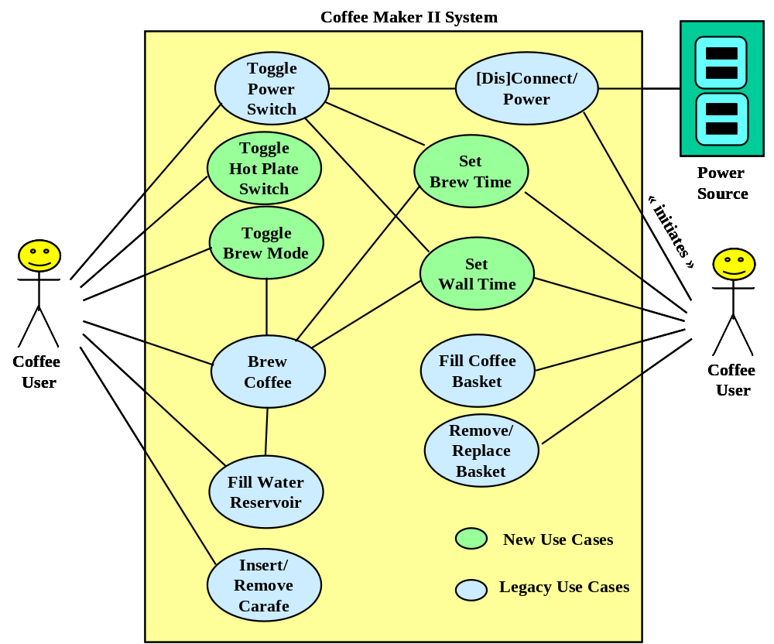

Figure 2.2-1. Use Case Diagram for Coffee Maker II System

Before any capability of the Coffee Maker II system can be activated, the Coffee User must plug the power cord of the Coffee Maker II system into the Power Source (connect power source). The Power Source must be a standard grounded wall outlet or the equivalent delivering 110 Volts of 60-cycle AC electric current.

Whenever the Power Source is connected to the Coffee Maker II system via the power cord and the power switch is in the ON position (set power switch), the system resets to its initial state where manual is selected as the default brewing mode, the hotplate is off, the time display is flashing “12:00 AM”, and the brew time is set to the default of “6:00 AM.” The internal clock will immediately start to update the time display (in a flashing mode) until the Coffee User resets the Hour, Minute, or AM/PM components of the display( set wall time).

The Coffee User can manually activate the brew cycle (brew coffee) by setting the brew mode to manual (set brew mode) and pressing the start brew button on the console.

The Coffee User can set the brew time by pressing the (auto brew) button on the console. The Coffee Maker II system responds by displaying the current brew time in the time display. This time can be changed (set brew time) using the Hour, Minute, AM/PM buttons on the console in the same way they are used to set wall time. The new brew time becomes installed when Coffee User presses the (auto brew) button a second time. The brew cycle will automatically begin (start brew cycle) when the wall time equals the brew time when the brew mode switch is set to automatic. If the brew mode switch is set to manual, the auto brew feature is not activated.

Prior to initiating a brew cycle, the Coffee User must ensure that the water reservoir is filled with water to the proper level (fill water reservoir), that coffee grounds have been placed in the coffee basket (fill coffee basket), and that the coffee carafe is in its proper position (insert carafe) on the hotplate under the coffee basket.
A lid on top of the Coffee Maker II system provides access to the water reservoir. The water level indicator on both sides of the water reservoir is graduated in cup units (6 oz.) giving the Coffee User a clear view of the water level during the filling process. The water reservoir is capable of holding a maximum of 72 oz.(12 cups).

The coffee basket is used to hold a coffee filter with grounds during the brewing cycle. Water drips from the reservoir into the coffee basket from the top. Brewed coffee drips from the bottom of the basket into the coffee carafe positioned below. A spring valve at the bottom of the basket is automatically opened when the carafe is in the proper position. If the carafe is removed (remove carafe) during the brewing cycle, the spring valve will close preventing the brewed coffee from dripping onto the hotplate and onto the floor. This feature avoids an annoying mess, should the Coffee User fail to place the carafe in its proper position to receive the brewed coffee. Since the coffee basket only holds two cups (12 ozs), it is imperative that the carafe be quickly returned to its proper place to avoid overflow. Finally, the coffee basked is removable to facilitate easy cleaning (remove/replace basket).

The coffee carafe is designed to hold 10% more than the capacity of the water reservoir to ensure no overflow will occur if the carafe is properly positioned throughout the brewing cycle. The carafe is also graduated to indicate the number of cups of capacity. It is therefore is the ideal vessel to use in filling the water reservoir.

2.2.2 CM2S Physical Design and User Interfaces (World Model)

Figure 2.2-2 illustrates the physical design of the proposed Coffee Maker II system.

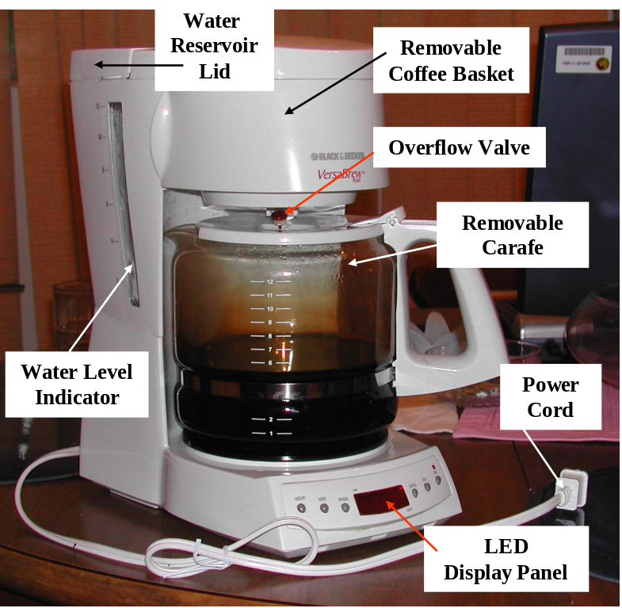

Figure 2.2-2. Coffee Maker II System Physical Design

Figure 2.2-3 illustrates the Control Console design. The three buttons on the left side of the console are used to set the time display by advancing “Hours”, “Minutes” independently until the desired value is reached. Both hours and minutes recycle back to zero when they reach their maximum. The “AM/PM” button is a toggle switch – alternating between “AM” and “PM” each time it is pressed.

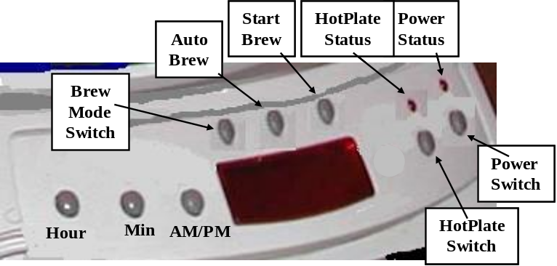
Figure 2.2-3. Control Console

The buttons on the right control the status of the power source and hotplate. These are toggle switches – alternating between “ON” and “OFF” each time the button is pressed. The “ON” condition is indicated by the status lights positioned above each button – they burn “red” when the corresponding switch is in the “ON” position.

The three buttons positioned above the time display control the brew cycle. The Brew Mode button is a toggle switch that determines the method by which the brew cycle is initiated – it alternates between “auto” and “manual” each time the button is pressed. The brew mode is displayed at the top of the time display panel under the Brew Mode button. Brew mode “manual” disables the brew timer and requires pressing the Start Brew button to initiate the brew cycle. When the brew mode is “auto” the Brew Time and the current wall time determine when a brew cycle begins. To set the Brew Time, the “auto brew” button is pressed. This displays the Brew Time on the time display. The time buttons (Hour, Min, AM/PM) can then be used to reset the Brew Time. When the “auto brew” is pressed a second time, the Brew Time is saved and the wall time is re-displayed in the time display panel.

2.2.3 CM2SS Operational Concept (The Simulator)

The CM2SS is a single-processor discrete-event simulator that shall be designed to run on both UNIX and Windows platforms. It offers a simple easy-to-use command line interface. All inputs and outputs are in the form of ASCII files with a user-friendly format for readability and maintainability. The CM2SS use cases are depicted in Figure 2.2-4 and described in the remainder of this section.

To simulate the Coffee Maker II System, the simulation user must first prepare a simulation input file, in an ASCII format specified in section 3.1, defining the modeling parameters of an instance of the CM2S. Once this done, the CM2SS is ready to run.

Execution begins by defining the simulation input file and the simulation output or log file. Use cases Define Simulation Input and Define Simulation Output interact with the simulation user to obtain valid host file names for these files. Once these use cases are completed, the simulator no longer interacts with the simulation user.

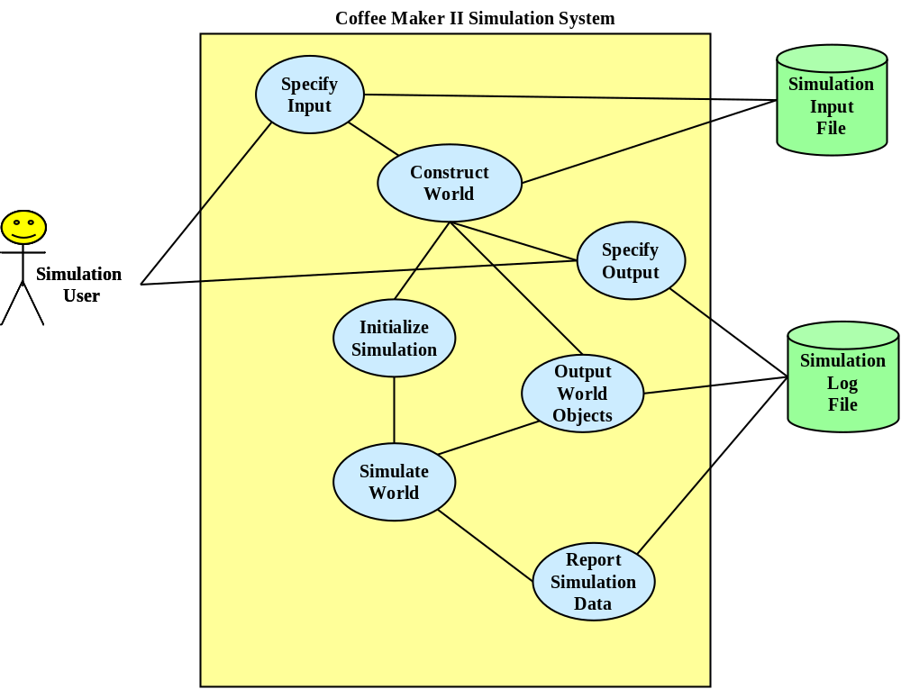

Figure 2.2-4. CM2S Simulator Use Case Diagram

The simulator next executes the Construct CM2S Instance. This use case parses the simulation input file to build an instance of the simulated world model. To confirm correctness and to record a persistent copy of the simulated instance, the constructed CM2S instance is output to the Simulation Log (Output CM2S Objects).

Finally, the CM2S instance can be initialized for simulation and then simulated. This use case is managed by the Initialize/Simulate CM2S. All simulated events are output to the Simulation Log during the simulation process. It is this time-flow of modeled events that define the behavior of the simulated CM2S instance. These events are defined by the use cases and interaction scenarios described generally in section 2.1.2 and 2.1.3 above and elaborated in detail in section 3.2.1.

Once simulation has completed, the Generate Post Simulation Analysis use case is executed to summarize and output statistics and other performance data. The detailed requirements for this use case are documented in section 3.1.2.

2.2.4 CM2SS User Interfaces (The Simulator)

The CM2SS user interface is very simple. The user must prepare an ASCII input file defining the simulation parameters necessary for creating the modeled instance of the CM2S. See section 3.1.1 for details. The CM2S Simulator is then executed from the command line with no additional parameters. During execution the Simulator will prompt the user for the external names of the simulation input and output files. Once this is complete, the Simulator will run to completion. Error messages will be sent to the standard error device while all simulation output will be captured in the simulation output file (simulation log).

2.3 User Characteristics

No special qualifications or training are required to operate the CM2SS.

2.4 Constraints

The software shall be written in C++ and shall successfully compile, link and run using g++ under a standard UNIX operating system and shall compile, link and run using Visual C/C++ (Ver 7.0) on Windows 2000, or XP operating systems.

Any design and implementation of the CM2SS shall be compliant with the software architecture and reusable components specified in this document.

2.5 Assumptions and Dependencies

All dependencies on and assumptions relating to third-party products, subcontractors, governmental laws and regulations, or finally on emerging industry standards should be discussed in this section. This section is important to help identify sources of project risk.

3.0 Specific Requirements

3.1 External Interfaces

3.1.1 CM2S Model Interfaces
Object Input Specifications
Object Output Specifications

3.1.2 CM2SS Simulator Interfaces
Input File Specification
Output File Specification
Post Simulation Report Specification

3.2 Product Functions

3.2.1 Use Case Specifications: CM2S

This section gives the detailed specifications for a subset of the use cases described in section 2.2.1. This SRS presents the Analysis Model view of use cases, that is, it presents an internal view of the components and objects of the simulated CM2S as they interact to realize each use case. Pre-conditions and Post-conditions are expressed in terms of CM2S states and interaction events involving actors of the CM2S as well as internal objects that are responsible for producing the desired response to external stimuli. Collaboration diagrams are used, where appropriate, to graphically depict interaction scenarios.

[Dis]Connect Power Source

ID: UC1

Purpose

The purpose of the Connect Power Source use case is to provide electrical power to the Coffee Maker II system.

Pre-condition

The power cord plug is not connected to an electric wall outlet with ground socket, or any other source of electric power.

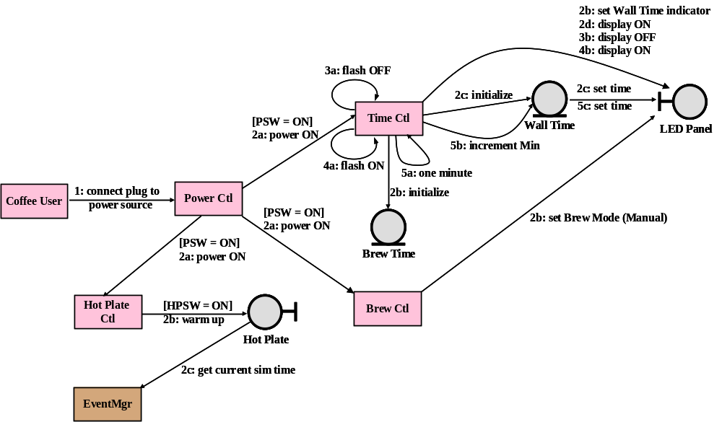

Figure 3.2.1-1. Collaboration Diagram for Connect Power Source

Scenario

    - Coffee User sends the message, “connect plug to power source”, to Power Ctl.
    - [if Power Switch (PSW) is OFF] Power Ctl initializes its self.
[if Power Switch (PSW) is ON] then
(a) Power Ctl, sends a “power ON” message to Time Ctl, Hot Plate Ctl, and Brew Ctl. All messages require zero delay and arrive at the same time.
    - Brew Ctl responds to the “power ON” signal by initializing itself and setting the Brew Mode to “manual” on the LED Panel.
    - Hot Plate Ctl responds to the “power ON” signal by initializing itself and, if the Hot Plate Switch is in the ON position (HPSW = ON), a call is made to the Hot Plate to “warm up”. NOTE: initially, HPSW = OFF, but the Coffee User may have previously changed the HPSW before initiating this use case. The Hot Plate records the time of the “warm up” signal so that it may compute its current temperature upon request. The Hot Plate records the current simulation time by calling a service of EventMgr.
    - Time Ctl responds to “power ON” by making “initialize” calls to both Wall Time and Brew Time. This causes these objects to establish their default values
(“12:00 am” for Wall Time and “6:00 am” for Brew Time).
Post-condition

The plug is securely mated with the wall outlet.

3.2.1.2 Set Brew Time

ID: UC2

Purpose

The purpose of the Set Brew Time use case is to set the Brew Time in preparation for activating the automatic brew function.

Pre-conditions

The Power Source is connected to the Coffee Maker II system. The Power Switch (PSW) is set to the ON position (Power Status light is red). The “wall time” indicator and current Wall Time is being displayed on the LED panel.

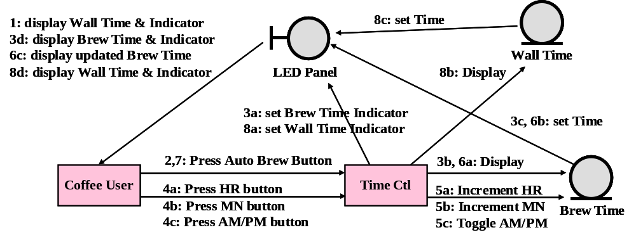
Figure 3.2.1-2. Collaboration Diagram for Set Brew Time

Scenario
    - The LED Panel is displaying the “wall time” indicator and the current value of Wall Time.
    - Coffee User sends a “press Auto Brew button” to Time Ctl.
    - (a) Time Ctl calls LED Panel to “set Brew Time Indicator”.
(b) Time Ctl calls Brew Time to “display” its value.
(c) Brew Time calls LED Panel to “set time” passing its current value.
    - The Coffee User sends zero or more of the following messages to Time Ctl until the desired Brew Time appears on the LED Panel.
(a) “Press HR button”
(b) “Press MN button”
(c) “Press the AM/PM button”
    - In response to the corresponding message received from Coffee User, Time Ctl:
(a) calls Brew Time to increment Hours.
(b) calls Brew Time to increment Minutes.
(c) calls Brew Time to toggle AM/PM.
    - After each instance of 5(a)-(c), Time Ctl calls Brew Time to display its current value. Brew Time responds by calling LED Panel to “set time” passing its current value.
    - [LED Panel displays desired Brew Time] Coffee User sends a “press Auto Brew button” to Time Ctl.
    - Time Ctl responds to 7. by (a) calling LED Panel to “set Wall Time indicator”, and (b) calling Wall Time to “display” its current value. Wall Time responds by calling LED Panel to “set time” passing its current value.
NOTE: Concurrent with the above scenario, Time Ctl is sending itself periodic messages (one per minute) to “update Wall Time” by incrementing minutes. Wall Time is NOT called to “display” its current value while this use case is in progress.
Post-condition
The LED panel indicates “wall time” and displays the current value of Wall Time. The internal value of Brew Time has been updated.

3.2.1.3 Brew Coffee

ID: UC3

Purpose

The purpose of the Brew Coffee use case is to execute the primary function of brewing coffee.

Pre-conditions

The Power Source is connected to the Coffee Maker II system. The Power Switch (PSW) is set to the ON position (Power Status light is red). The “wall time” indicator and current Wall Time is being displayed on the LED panel. The brew mode is manual and the Coffee User has pressed the Start Brew button, or the brew mode is auto brew and the Wall Time equals the Brew Time on the next time advance event.

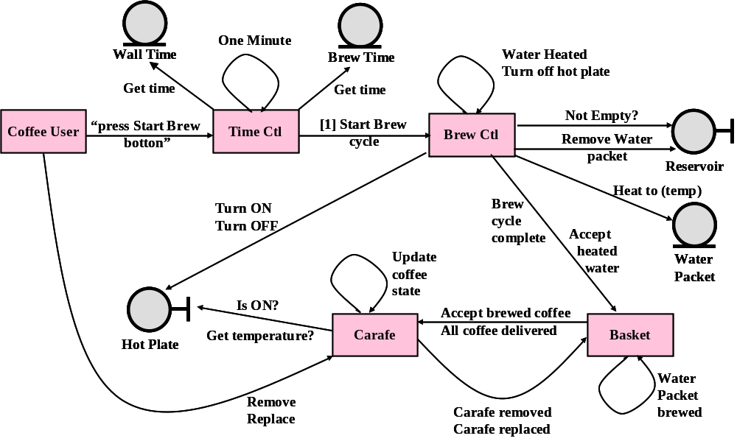

Scenario
- When the brew pre-conditions have been met, Time Ctl sends a “start brew cycle” message to Brew Ctl.
- In response to 1, Brew Ctl checks the Reservoir to see if it is empty. If not, the remaining steps are excecuted, otherwise Brew Ctl takes no further action.
- Brew Ctl turns the Hot Plate “ON” and removes a water packet from the Reservior. It then sends itself a message to “water heated”. This message is delayed to allow for heating the current water packet to the appropriate brew temperature.
- Upon receiving the “water heated” message, Brew Ctl updates the temperature of its current water packet and sends the water packet to the coffee Basket (“accept heated water”).
- Brew Ctl then checks the Reservoir to see if it is empty. If not, Brew Ctl removes a water packet from the Reservior. It then sends itself a message “water heated”. Step 4 and 5 are repeated until the Reservoir is empty.
- When the Reservoir is empty, Brew Ctl sends a message “brew cycle complete” to the Basket, and sends itself a message to “turn OFF Hot Plate” – this message is delayed for two hours.
- When the Basket receives the message “accept heated water”, it sends itself the message, “water packet brewed”, delayed to account for the time required to transform one packet of hot water into coffee ready to deliver to the Carafe.
- The Basket may receive asynchronous messages from Carafe indicating that has been removed from its brew position or returned to its brew position. Basket responds by setting the state of its coffee release valve. Furthermore, Basket may receive an asynchronous message from Brew Ctl that the “brew cycle is complete”. Basket responds by updating its internal state.
- When Basket receives its own message that a water packet has been brewed, it internally queues the last water packet received from Brew Ctl. It then updates the temperature of each coffee packet in its internal queue. Next, Basket checks the state of its release valve.
- (a) If the valve is open and the internal queue is not empty, Basket removes the oldest coffee packet from its internal queue and sends a message containing the coffee packet to Carafe to “accept brewed coffee.” If Basket has not been notified that the brew cycle is complete, it waits in a state that will accept messages from Brew Ctl. Otherwise, enters a state that only responds to messages from Carafe.
- (b) If the release valve is closed, Basket checks the length of its internal queue. If it has exceeded its overflow limit, then it removes the oldest coffee packets from its internal queue to bring it within the overflow limit and outputs an overflow message to the simulation log.
- When the coffee packet queue is empty and Basket has received the message from Brew Ctl that the brew cycle has completed, then Basket sends a message to Carafe that “all coffee has been delivered.” Clearly this is possible only when the release valve is in its open state.

Post Condition

TBD

3.2.1.4 Set Wall Time

ID: UC4

Purpose

The purpose of the Set Wall Time is to set the value of Wall Time displayed on the LED.

Pre-conditions
The Power Status is ON. The Wall Time indicator and value are displayed on the LED.

Scenario

Post-condition
The LED shows the desired value of Wall Time and its indicator

3.2.1.5 Fill Coffee Basket

ID: UC5

Purpose
The purpose of this use case is to enable the Coffee User to add coffee grounds and a filter prior to execution of the Brew Coffee use case.

Pre-conditions
The Coffee Maker II system is not currently executing use case UC6 (Brew Coffee).

Scenario

Post Condition
The Coffee Basket contains coffee grounds (and a filter) and is in its closed position for brewing.

3.2.1.6 Remove/Replace Basket

ID: UC6

Purpose
The purpose of the Remove/Replace Coffee Basket use case is to enable the Coffee User to clean the Coffee Basket and optionally add coffee grounds and a filter prior to execution of the Brew Coffee use case.

Pre-conditions
The Coffee Maker II system is not currently executing use case UC6 (Brew Coffee).

Scenario

Post Condition
The Coffee Basket is in its closed position for brewing.

3.2.1.7 Insert/Remove Carafe

ID: UC7

Purpose
The purpose of the Remove/Insert Carafe use case is to remove the Carafe for cleaning prior to executing the Brew Coffee use case. To remove the Carafe during the Brew Coffee use case to pour a cup of freshly brewed coffee.

Pre-conditions
The Carafe is in its proper position on the Hot Plate under the Coffee Basket. The Coffee Basket is in its closed position.

Scenario

Post Condition
Same as the Pre-conditions.

3.2.1.8 Fill Water Reservoir

ID: UC8

Purpose
The purpose of the Fill Water Reservoir use case is to add water to the Water Reservoir in preparation for the Brew Coffee use case.

Pre-conditions
The Water Reservoir must not be completely filled.

Scenario

Post Condition
The Water Reservoir is not empty.

3.2.1.9 Toggle Brew Mode

ID: UC9

Purpose
The purpose of the Toggle Brew Mode use case is alternate the Brew Mode between its two values of automatic and manual.

Pre-conditions
The Power Status is ON. The LED displays the current status of Brew Mode and the current value of Wall Time.

Scenario

Post Condition
The Brew Mode status on the LED has changed its value. The current value of Wall Time and its indicator continue to be displayed on the LED.

3.2.1.10 Toggle Hot Plate Switch

ID: UC10

Purpose
The purpose of the Toggle Hot Plate Switch use case is to toggle power to the Hot plate.

Pre-conditions
The Power Switch is ON position.

Scenario

Post Condition
The Hot Plate Status light shall indicate the new status of the Hot Plate.

3.2.2 Operational States: CM2S

The behavior of the Coffee Maker II is determined by the state of several independent components. The Coffee User needs to know and control whether or not the system is “brewing”, whether or not the hotplate in “on”, whether or not the power is “on”, the value of wall time, the value of brew time, and finally, what brew mode the system is in. Several interaction events and conditions trigger changes in the behavior state. These states and the events that trigger transitions between states are defined in this section.
Power-ON: the Power Source is connected AND the Power Switch is in the “ON” position; otherwise the system is in the Power-OFF condition.

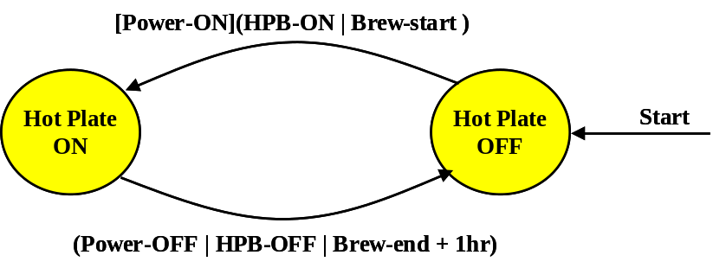

Figure 3.2.2-1. Transitions Controlling the Hotplate.

Figure 3.2.2-1 describes the events and conditions that determine whether or not the Hotplate is on. The Hotplate can be “ON” only if the system is in the Power-ON state. The transition to “Hotplate ON” will then occur if either the hotplate button is toggled to the “ON” position (HPB-ON), or the brew cycle has begun. The transition back to the “Hotplate OFF” will occur if a Power-OFF condition arises or the hotplate button is toggled “OFF”, or finally, if one hour has elapsed since the end of the last brew cycle. All other system events leave the hotplate in a stable state.

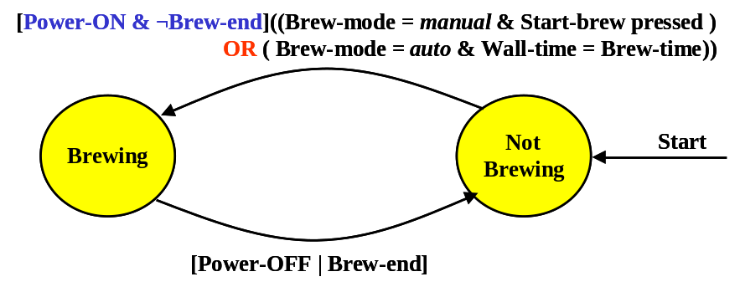
Figure 3.2.2-2. Transitions and Events Controlling the Brew Cycle.

As with the hotplate, a pre-condition to starting a brew cycle is that the system be in a Power-ON condition and the Brew-end condition is not met (sufficient water in the reservoir). Given this, Figure 3.2.2-2 shows that a brew cycle begins if the Brew Mode switch has been toggled to the manual position and the Start Brew button has been pressed. Alternatively, in auto brew mode, the triggering event is a signal that the Brew Time equals the Wall Time. Brewing terminates if a Power-OFF condition arises or the Brew-end condition holds. The Brew-end condition is true if the water sensor in the water reservoir detects that there is less than one cup (6 ounces) of water volume remaining.
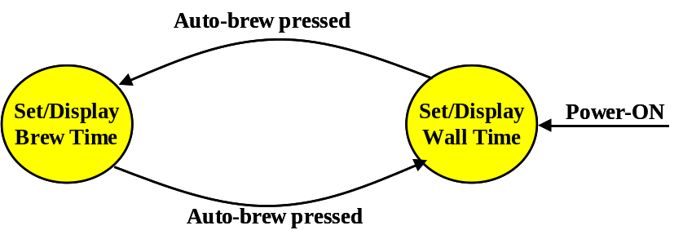

Figure 3.2.2-3. Time Display Control States and Transitions

The Time Display(TD) contains a digital LED output device that displays the value of the internal wall clock timer or the value of the brew timer depending on the number of times the Auto-brew button has been pressed. While the Power-ON condition holds, an even number of Auto-brew presses (including none) leave the TD device in the “Set/Display Wall Time” state where it takes its input from the Wall Timer, otherwise the TD is in the “Set/Display Brew Time” state where it takes its input from the Brew Timer. These two states also determine the effect of pressing the Hour, Min, and AM/PM input buttons on the Control Console. These transitions are shown in Figure 3.2.2-3.

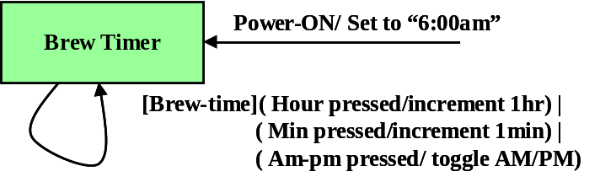

Figure 3.2.2-4(a). Brew Timer Control and Transitions

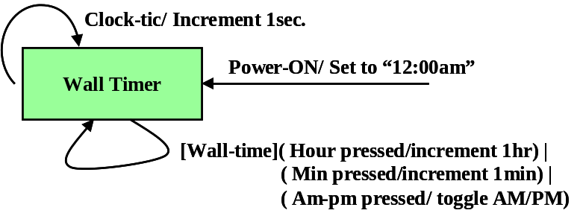

Figure 3.2.2-4(b). Wall Timer Control and Transitions

As shown in Figures 3.2.2-4(a) and 3.2.2-4 (b), the Brew Timer is set initially to “6:00am” and the Wall Timer is set to “12:00am” when the Power-On condition holds true. The Time Display is in the “Set/Display Brew Time” state, then the Hour, Min, AM/PM buttons enable the Coffee User to change the Brew Timer. Similarly, when the Time Display is in the “Set/Display Wall Time” state, these button enable the Coffee User to change the Wall Timer. The primary difference between these two timers is that the Wall Timer is continuously incremented every second while the Power-ON condition holds.

3.2.3 Use Case Specifications: CM2SS

This section describes the major functions of a typical discrete-event simulation, and of the CM2SS, in particular. These functions, listed in essentially the order they normally occur, are the following:
- Define all simulation input files or sources. Define all output files or sinks.
The CM2SS requires one primary ASCII input file and one primary output file, the Simulation Log.
- Construct an instance of the world model – the object to be simulated. This function processes the necessary input files and builds the specific world instance to simulated (step 4).
- Output all or part of the world model. Output of the complete world instance is typically performed once before simulation begins to permit verification that the correct world instance was constructed. In addition, the complete world instance is output once after simulation has completed to present the final state of the world and to facilitate verification of simulation correctness. Output during simulation may take a variety of forms, but at a minimum it shall include a description of each event produced in time order and in an order consistent with cause-effect. The dynamic state of the world instance and/or some or all of its component objects, and the dynamic relationships and behavior of component objects may be depicted on various graphical displays or captured in the simulation log during the simulation.
The output requirement for the CM2SS during simulation is only to produce a description of events on the simulation log. Details are provided in section 3.1.
- Initialize and Simulate the world instance. Initialization involves two functions: (a) distributing object identities among the various “players” that need to communicate at some point during the simulation (these take the form of object handles or pointers), and (b) providing each simulation Agent an opportunity to post events that prime the event queue – at least one event must be generated before simulation can begin. Once Initialization is complete, Simulation can begin. This is a simple and straightforward process of processing events in time, cause-effect, order until the event queue becomes empty. Processing an event involves dispatching the event message to the Agent identified as the receiver of the message. The simulation cycle outputs the image of each dispatched event to the simulation log.
- Post simulation analysis and reporting. Once simulation is complete, the final state of the world instance can be examined together with other persistent data produced during simulation to produce a summary report. This report can take a variety of forms (graphical displays, ASCII output to simulation log) and can serve a variety of purposes to the CM2SS user. In general, this “after action review” is designed to provide performance data and to quantify evaluation criteria that measure the relative success of the simulation toward meeting its design goals.
For the CM2SS, the only performance data that shall be reported are the following. Detailed output specifications for this report are given in section 3.1.
> Total length of simulation.
> Total number of simulation events
> Simulated time required to complete a brewing cycle
> Maximum amount of simulated time the carafe can be removed during
the brewing cycle before the coffee basket overflows.
> Temperature of heated water entering coffee basket. Temperature of coffee
exiting coffee basket. The difference between these two temperatures.
> Temperature variation of coffee in the carafe over the time span of the
brewing cycle.
> Number and duration of each period the carafe was removed from the hot
plate during the brewing cycle.

3.2.4 Operational States: CM2SS

The operational states of the CM2SS and the use case transitions between them are illustrated in Figure 3.2.4-1.

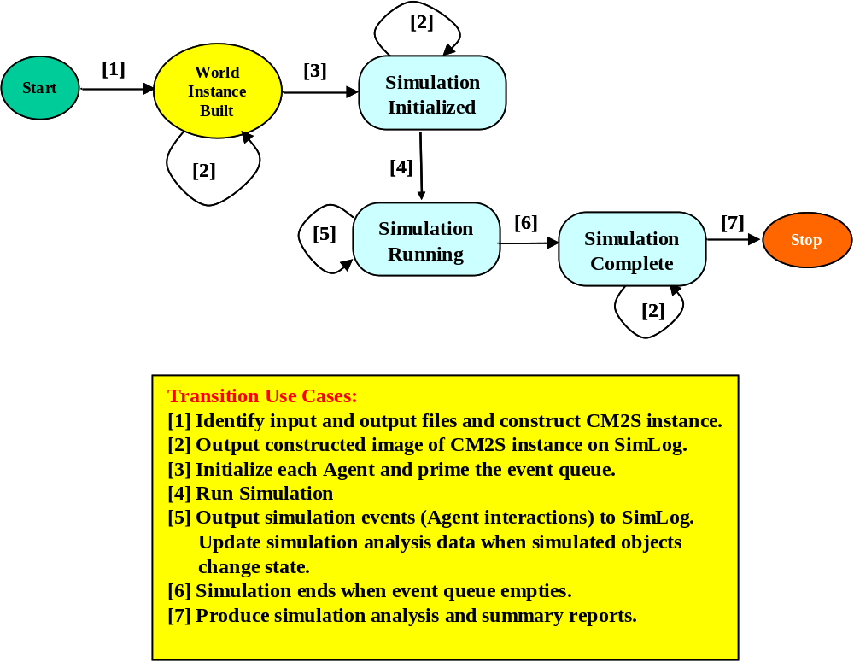

Figure 3.2.4-1. CM2SS States and Transitions.

3.2.4 Functional Requirements

The requirements, both functional and non-functional requirements, for the Coffee Maker II system are summarized in this section. These requirements have been elicited from the following sources.

- Use Case Model document, sections 1.0 and 2.0.
- Private interviews with Dr. David Workman, Senior Scientist for CafAdiksTM, Inc.

Req ID | Description | Section/  Para.
F1 | The Coffee Maker II system shall brew coffee, that is, produce hot liquid coffee by blanching coffee grounds with hot water. | [1]1.3[Para.1]  2.6
F2 | The Coffee Maker II system shall provide two modes for activating the brew cycle: (a) manual, and (b) automatic. The automatic mode shall be controlled by a time mechanism that permits the Coffee User to specify the time of day in Hours/Minutes AM/PM at which the brew cycle shall be activated (when the Power is ON). | [1]1.3[Para.1]  [Para.6]  [Para.7]  2.3,2.4
F3 | The Coffee Maker II system shall be powered by standard 110V house current via grounded 3-prong plug and power cord. | [1]1.3[Para.2]  [2]
F4 | The Coffee Maker II system shall provide a Power Switch that provides a convenient mechanism for disabling/enabling the Power Source and resetting the CM-II to its default settings without having to unplug the Coffee Maker from the Power Source. | [1]1.3[Para.3]  [Para.5]  [2]
F5 | The Coffee Maker II system shall provide an LED for displaying time and status information to the Coffee User. In particular, the time shall be displayed in Hours and Minutes, AM or PM, and with an indicator designating whether the time value is brew time or wall time. The Brew Mode (automatic or manual) and the brew status (brewing or not) shall also be displayed on the LED. | [1]1.3[Para.4],  [Para.6]  1.4.1,2.3,2.4,  2.5,2.6
F6 | The Coffee Maker II system shall provide a status indicator light on the Console for Power (ON/OFF). | [1]1.3[Para.3]
F7 | The Coffee Maker II system shall provide a status indicator light on the Console for the Hotplate (ON/OFF). | [1]1.3[Para.12]  1.4.1
F8 | The Coffee Maker II system shall provide an interface for setting Brew Time. | [1]1.3[Para.5]  [Para.7]
F9 | The Coffee Maker II system shall provide an interface for setting Wall Time. | [1]1.3[Para.5]  [Para.13]
F10 | The Coffee Maker II system shall provide a convenient mechanism for filling the Water Reservoir prior to executing the brew cycle. | [1]1.3[Para.8]  [Para.9]
F11 | The Coffee Maker II system shall provide a convenient mechanism for adding coffee grounds and a filter to the Coffee Basket prior to executing the brew cycle. | [1]1.3[Para.8]  [Para.10]
F12 | The Coffee Basket of the Coffee Maker II system shall be removable for cleaning. | [1]1.3[Para.8]  [Para.10]
F13 | The Coffee Maker II system shall provide independent manual control over the Hotplate that maintains a heat source to the Carafe when filled with brewed coffee. | [1]1.3[Para.12]
F14 | The Hotplate of the Coffee Maker II system shall be controlled automatically by the brew cycle (turn ON), and by a two-hour count-down timer that shuts OFF the Hotplate. | [1]1.3[Para.12]

3.3 Performance Requirements

The design constraints fall into three categories: safety, performance, and usability. The requirements in each of these categories are enumerated in this section as they are understood at this point in development.

3.3.1 Safety Requirements

- Power cord is a three-pronged plug to ensure proper grounding through the Power Source.
- The hotplate has a one-hour timer that will place it in the OFF state after one hour elapses beyond the end of the brew cycle in its ON state.
- The coffee basket is equipped with a spring valve that automatically shuts off the flow of brewed coffee when the carafe is removed from its position on the hotplate. As a safety feature this requirement reduces the potential for overflow water causing damage to the environment as well as the electrical components of the Coffee Maker II itself. This is also a convenience to the Coffee User by permitting the carafe to be removed for a brief time period (early cup of coffee) and replacing it before the coffee basket capacity is exceeded.
- The electrical components shall be encased in water tight compartments so that the base of the Coffee Maker II can be submerged in water (for cleaning) without causing electrical faults, or without endangering the Coffee User with electric shock.

3.3.2 Performance Requirements

- The Power Source shall provide a grounded source of 110 Volt AC current.
- The power cord shall be made of break resistant and cut resistant non-conductive material such as rubber or plastic.
- The brew capacity of the water reservoir shall be 12, 6-ounce cups. The capacity of the carafe shall be 10% larger than the reservoir capacity.
- The brew temperature of the water shall be between 150º – 175º Farenheit.
- The coffee basket shall be removable for ease of cleaning.
- The weight of the Coffee Maker II system shall not exceed 2.5lb.

3.3.3 Usability Requirements

- The water reservoir shall have an external, graduated volume indicator (in cups) on both sides to facilitate filling the reservoir to the desired level.
- The Control Console shall be easy to read and understand so that 85% of the Coffee Users will not require a user manual to operate the Coffee Maker II.

Logical Database Requirements
None.

3.5 Design Constraints
None.

3.6 Software Quality Requirements
See Section 3.3.

3.7 Object Models

3.7.1 Software Architectural Overview

The organization and architecture of the CM2S simulator has four components, three reusable components and one component that is application specific, that is, specific to the particular “world” being simulated. All components, save one, are organized as packages or subsystems. The non-package in the architecture is the main procedure or class, it creates the one and only execution thread and defines its unique starting point. The figure below illustrates these components and the overall functional responsibilities.

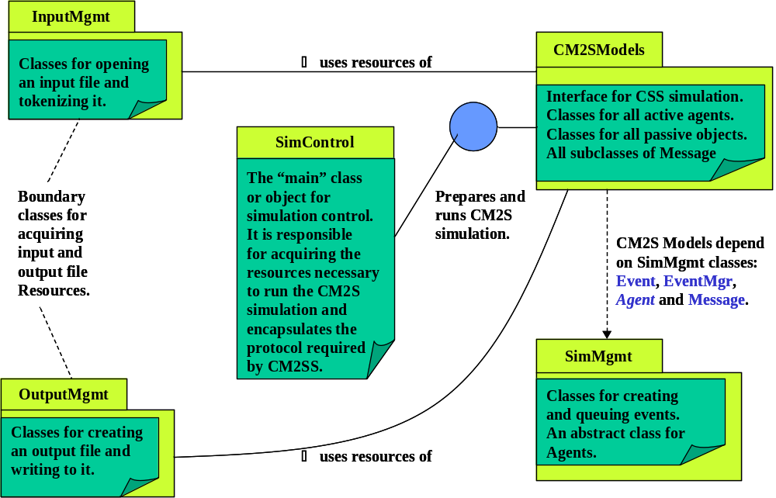

Figure 3.7-1. Software Architecture of the CM2SS

Iomgmt is a reusable, application independent package containing several boundary classes for opening input files, parsing input files, and creating output files.

SimMgmt is a reusable, simulation independent package that defines the invariant simulation infrastructure classes necessary to support the SimModels package. SimMgmt implicitly establishes a protocol for how classes and objects in SimModels must interact with each other. SimMgmt is composed of four key classes: Event, EventMgr, Agent, and Message. These classes are completely reusable without change across a wide collection of discrete-event simulation models.

SimModels contains the simulation specific classes. SimModels must always define a “world” class or object that realizes the only public interface to the simulation models. For the Coffee Maker II system, the world class is CM2S. Interaction with this world class must follow a particular protocol to create an instance of the simulated world, initialize or ready the world for simulation, to perform the world simulation, and then, finally, to report on simulation results.

SimControl is the main procedure or class that encapsulates the protocol necessary to perform the simulation applicaton. This is the program entry point and creates the single execution thread.

See section 3.7.2 for a more detailed description of these packages and the classes they contain.

Simulated Objects

A static view of the simulated Coffee Maker II System is shown in Figure 3.7-2. Control objects (simulation Agents) are denoted by boxes and are colored in red. With the exception of the water Reservoir, all boundary objects depicted produce CM2S output. The mapping of simulated objects into the generic layered simulation architecture is shown in Figure 3.7-3 below. The rationale for this design is as follows:
(a) All inputs to the CM2S are simple buttons. We have chosen to model button-press events as messages sent by the Coffee User to the appropriate CM2S agents (Power Ctl, Time Ctl, or Hot-Plate Ctl).
(b) The water Reservoir, the only input boundary object, is explicitly modeled because it does provide an output function through the water level indicator, but more importantly it is a more complicated input object. Its non-trivial nature arises from the way the Brew Ctl mechanism must interact with it. During the brew cycle, Brew Ctl must periodically sense the state of the Reservoir to determine if it is empty or not, and, if not, then consume some amount of water for heating purposes.

(c) Both the Basket and Carafe are boundary objects, and serve a dual input and output function. However, the relationship between Brew Ctl, the Basket, and the Carafe is a non-trivial one. Heated water packets (quanta) must flow from Brew Ctl to the Basket at some periodic rate. Heated water packets interact with the coffee grounds in the Basket to become heated coffee packets which then flow into the Carafe – provided, of course, that the Carafe is in place to receive the coffee packets. Thus the Basket is a shared buffer between Brew Ctl and the Carafe. Furthermore, the coffee grounds cause a delay in the water flow and may actually cool the water during its transformation into coffee. All these effects may need to be modeled and require that the Basket be modeled as an Agent in the simulation.
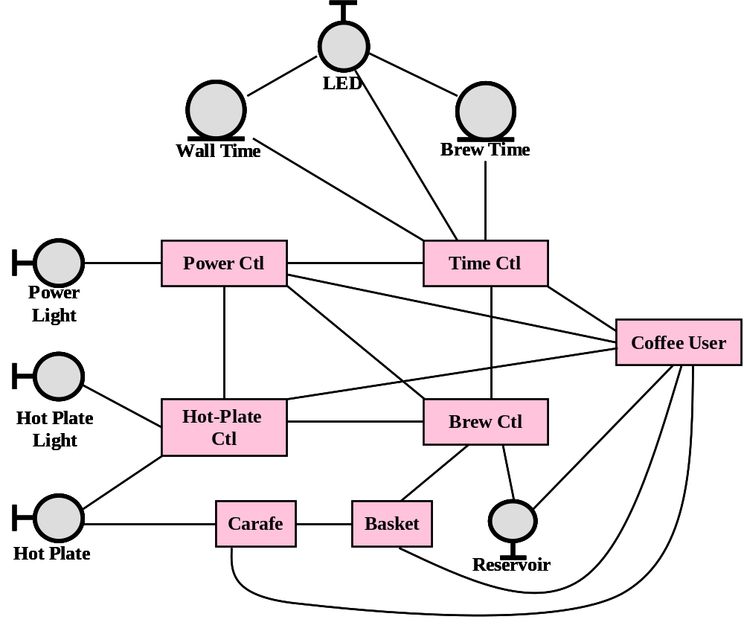

Figure 3.7-2. CM2S Class Diagram for Simulated Objects

(d) The primary purpose or function of the Carafe is really as boundary output object. It has an association with the Hot Plate which acts as a heating source while the Carafe is in its normal position during the brewing cycle of the CM2S. The Carafe also receives coffee packets from the Basket when it is in its normal position. Finally, the Carafe’s position (normal or removed) is controlled by the Coffee User. When the Carafe is removed from the Hot Plate, it can no longer receive heat and begins radiating heat energy to the ambient environment. In the removed state, it cannot receive coffee packets from the Basket. Because of these dynamic interactions with other CM2S objects, the Carafe must also be modeled as a simulation Agent.
The Layered View of SimModels and SimMgmt

The classes and objects described in the previous subsection are organized into well-defined software layers. This layered organization is depicted in Figure 3.7-3. The purpose of each layer is briefly described in this subsection.
Control Layer. The Control Layer is composed of the three classes: CM2S (the world class ), EventMgr, and Event. CM2S defines the public interface for the simulated world instance and logically encapsulates all computational models comprising the simulated world instance. EventMgr encapsulates the queue of Event instances that defines the chronological flow of interactions among Agent subclasses.

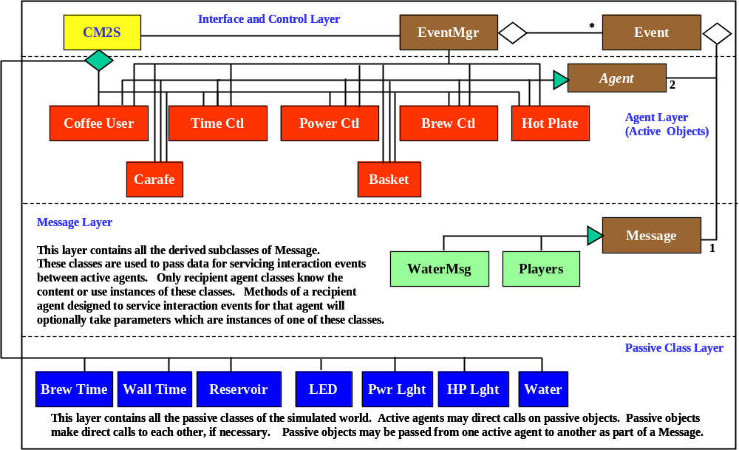

Figure 3.7-3. CM2SS Layered Architecture

EventMgr imposes and maintains an order on Event instances by their simulation time and preserves cause-effect order for Events that occur simultaneously. Each instance of class Event encapsulates a simulation time, a sender and receiver Agent, and a Message instance. The Message instance defines a request for action by receiver Agent and, for subclasses of Message, carries data objects that are required to execute the action. Simulation progress under control of the Simulate() method of CM2S. This method is a continuous loop, removing Event instances from the EventMgr and dispatching them to the receiver Agent. This continues until the event queue empties out.

The Control Layer communicates or interacts primarily with Active Agent Layer. CM2S is responsible for creating instances of all Active Agents and some objects in the Passive Layer (e.g., Reservoir), and finally an instance of the Players class in the Message Layer. It is also responsible for calling the Initialize() method of each Active Agent before simulation begins, and finally it is responsible for processing events (writing them to the simulation log and dispatching them to receiving Agents).

Active Agent Layer. All classes in this layer must be subclasses of the abstract class, Agent. Agents (instances of these subclasses) are the objects that actively interact to realize the effect of the simulation. Agents communicate with each other by creating instances of Events and posting them with the EventMgr. Actions requested of a receiver agent by a sender Agent are described by an instance of some class in the Message Layer. Agents modify their behavior as the result of responding to Events (messages) for which they are designated as the receiver. This behavior is executed by each agent’s dispatch() method. Dispatching one event typically results in posting more events defined to occur sometime in the future. Although an agent can post an event that is to occur “instantaneously” (at the current simulation time – these are called lightspeed events ), no agent is permitted to create events that are to occur in the “past”.

Agents may be associated with objects in the Passive Layer. All interactions between agents and Passive objects are via direct method call. Such calls may indirectly trigger calls to other Passive Layer objects. However, Passive Layer objects are not permitted to call objects in any of the other layers.

As part of the action executed by an agent in response to an event, the simulation time spent in interacting with Passive objects must be accumulated and “charged to” the time delay calculated for the next interaction with another agent. Consequently, the “cost” of interacting with Passive objects is factored into the time delay between interactions with agents.

Message Layer. The Message Layer is a collection of subclasses, rooted at class Message, that provide the sole means by which objects in the Active Agent Layer communicate. An instance of any of these classes will be referred to simply as a message. As a general rule, messages carries two important items of information: first, an integer code, understood only by the receiver agent of an event, and used by the receiver’s dispatch() method to identify the internal handler method assigned to respond to the message; and optionally second, any data objects that might be required by the internal handler to execute the proper response. An instance of the root class, Message, can be thought of as a “signal” to the receiver that some event has occurred – many messages or interactions between agents are of this kind, a simple notification that something has happened that may required the attention of the receiver.

Instances of the Message Layer classes are created by instances of the Active Agent Layer and used to construct Event instances that are posted by agents to the EventMgr in the Control Layer. A message does not make any secondary calls except for a required output method that writes the message image to a designated output stream (SimLog). If a message is used to transport a data object, then the class for that data must also provide an output method that will write its image to the output stream. The output method for messages also writes a description (specified as a parameter to the message constructor) to the output stream. This description should explain the reason for the message so that when reading the simulation log, the user will easily understand the flow of events and what is happening at a given point in simulation time.

Passive Layer. The Passive Layer contains all classes required by the other layers to support the simulation. Defining classes of data carried by messages belong to this layer. As mentioned above, interactions between agents and passive objects, or interactions between distinct passive objects are effected by direct method calls. Simulation time consumed by such interactions must be accounted for in interactions between agents.

The Dynamic View

This subsection summarizes the dynamic behavior of components of the simulation. In particular, the Agent Interaction Table (below) summarizes the interaction scenarios defined by the various use cases presented individually in section 3.2.1. This table presents the Agent interactions essentially in the order they would occur when the Coffee User follows a nominal coffee making scenario, beginning with connecting the power source and ending with removing the carafe filled with brewed coffee. In the CM2SS, simulation begins after construction and initialization of the world instance (CM2S). The initialization process primes the EventMgr (instance) with an initial set of events. When SimControl invokes the Simulate() method of CM2S, events are dispatched in time sequence until the EventMgr indicates the event queue is empty.
The column labeled “Time Delay” defines the name(s) of the simulation input parameter(s), if required, that determine the number of simulation clock ticks necessary for the message to arrive at the Recvr agent relative to the time it is posted to the EventMgr by the Sendr agent. These parameters are always defined in the Sender agent and input when the agent object is constructed.

Table 3.7.1-1. Agent Interaction Table
# | Sendr | Recvr | Message  Purpose | Data  Content | Time  Delay | Message  Class
1 | Coffee  User | Power  Ctl | Insert plug into power source. | None | Connect_plug | Message
2 | Coffee  User | Power  Ctl | Turn on power switch. | None | Toggle  _switch | Message
3 | Power  Ctl | Brew  Ctl | Signal “power on” status.  Condition: power switch is in the ON position. | None | none | Message
4 | Power  Ctl | Hot-Plate Ctl | Signal “power on” status.  Condition: power switch is in the ON position. | None | none | Message
5 | Power  Ctl | Time Ctl | Signal “power on” status.  Condition: power switch is in the ON position. | None | none | Message
6 | Time  Ctl | Time  Ctl | “Flash off” LED display.  Condition: power is ON and Time Ctl is in its initial state. | None | Flash  _delay | Message
7 | Time  Ctl | Time  Ctl | “Flash on” LED display.  Condition: power is ON and Time Ctl is in its initial state. | None | Flash  _delay | Message
8 | Time  Ctl | Time  Ctl | Advance time by one minute.  Condition: power is ON. | None | One  _minute | Message
9 | Coffee  User | Time  Ctl | “press HR button” | None | Button  _press | Message
10 | Coffee  User | Time  Ctl | “press Min button” | None | Button  _press | Message
11 | Coffee  User | Time  Ctl | “press AM/PM button” | None | Button  _press | Message
12 | Coffee  User | Time  Ctl | “press Auto Brew button” | None | Button  _press | Message
13 | Coffee  User | Time  Ctl | “toggle Brew Mode” | None | Button  _press | Message
14 | Coffee  User | Basket | “open basket” | None | Open  _basket | Message
15 | Coffee  User | Basket | “close basket”  Note: this operation includes time to add coffee grounds. | None | Close  _basket | Message
16 | Coffee  User | Basket | “remove basket for cleaning” | None | none | Message
17 | Coffee  User | Basket | “replace basket after cleaning” | None | none | Message
18 | Coffee  User | Reservoir | “open lid to reservoir” | None | Lid  _operaton | Message
19 | Coffee  User | Reservoir | “add water” | Water | Cup_delay*  Water.Volume() | WaterMsg
20 | Coffee  User | Reservoir | “close lid to reservoir” | None | Lid  _operaton | Message
21 | Coffee  User | Carafe | “remove from brew position” | None | none | Message
22 | Coffee  User | Carafe | “replace to brew position” | None | none | Message
23 | Coffee  User | Time  Ctl | “press Start Brew button” | None | Button  _press | Message
24 | Time  Ctl | Brew  Ctl | “start brew cycle”  Note: Brew Ctl will turn Hot Plate ON when it receives this message. | None | none | Message
25 | Brew  Ctl | Brew  Ctl | “water heated”  Condition: Reservoir is not empty. | None | Heat  _cycle | Message
26 | Brew  Ctl | Brew  Ctl | “turn off Hot Plate”  Condition: Reservoir is empty at end of brew cycle. | None | Two_Hours | Message
27 | Brew  Ctl | Basket | “accept heated water” | Water | none | WaterMsg
28 | Brew  Ctl | Basket | “brew cycle complete” | None | none | Message
29 | Basket | Basket | “coffee packet has been brewed” | None | Flow  _rate | Message
30 | Basket | Carafe | “accept brewed coffee”  Condition: release valve in open position. | Water | none | WaterMsg
31 | Carafe | Basket | “carafe removed” | None | none | Message
32 | Carafe | Basket | “carafe replaced” | None | none | Message
33 | Basket | Carafe | “all coffee delivered” | None | Basket | Message
34 | Carafe | Carafe | “update coffee state”  Condition: Carafe is not empty. | None | One_Clock  _Tick | Message

3.7.2 Subsystem and Package Specifications

3.7.3 Class Specifications

3.8 Implementation Issues

